|  |
| --- |
| Close-up image showing the leaf-sides of two oversized books side-by-side on a bookshelf, with additional books in soft focus background |
| **Library management system**  ***Muhammad Taha(231661) & Moin Bukhari(231695)*** |
| |  |  |  | | --- | --- | --- | | Taha & Moin | 12/19/23 | Programming fundamentals | |

Programming Fundamentals

MUHAMMAD TAHA & MOIN BUKHARI

***Project: library Management system***

Overview:

This project is developed using only C++ with its integrated libraries. It only allows registered users to use the system and also has the functionality to add new users .It has a functionality to add and remove books that is only handled by admin.

**Main Features :**

* New user registration
* User authentication
* Admin authentication
* Book issuance
* Search functionality
* Shows user info and issued books
* Functionality to Add a book and remove a book
* Save every info in file

Management system has three pages

Admin page :

Admin has two options after he/she verify its authority by entering password.

Remove a Book : it asks user for book number after showing all books and as user enter a book number it removes the book and shows user books again .

Add a Book : It asks user for everything related to the book he or she want to add and then save it in file.

User page :

User page will first confirm whether the user is the registered user by asking file id and password ,

After that system will give him two main options

Search a book or see all the available books

In search a book there are further 3 option search by name ,search by book id and search by book author name and as book is found it let user confirm book issuance once confirmed it will show user its issued books.

Note that system has put the validation of entering only three books maximum more than 3 books entrance will show the message of books issuance limitation.

New user page

New user page is for registration where it ask user about its bio and ask if user is Air university student if he is it will allow user to make his account.

**Functions (**made by us**) :**

* User login
* New user login
* Add a book
* Remove a book
* Issue book
* Search a book

**Libraries we used:**

#include<iostream>

#include<fstream>

#include<string>

#include<cstdio>

#include<chrono>

#include<thread>

N

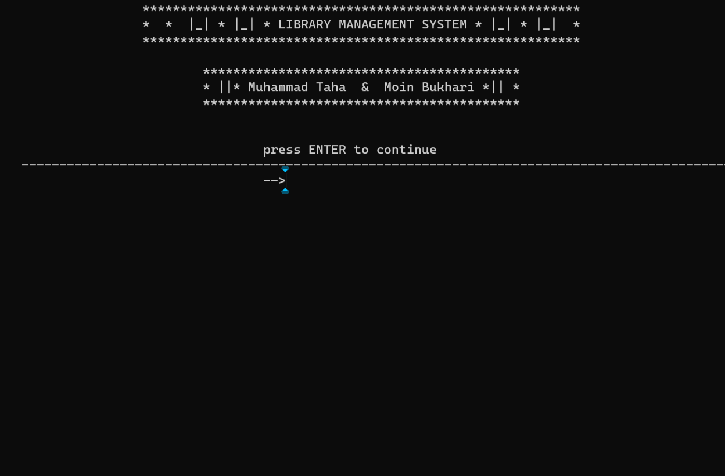

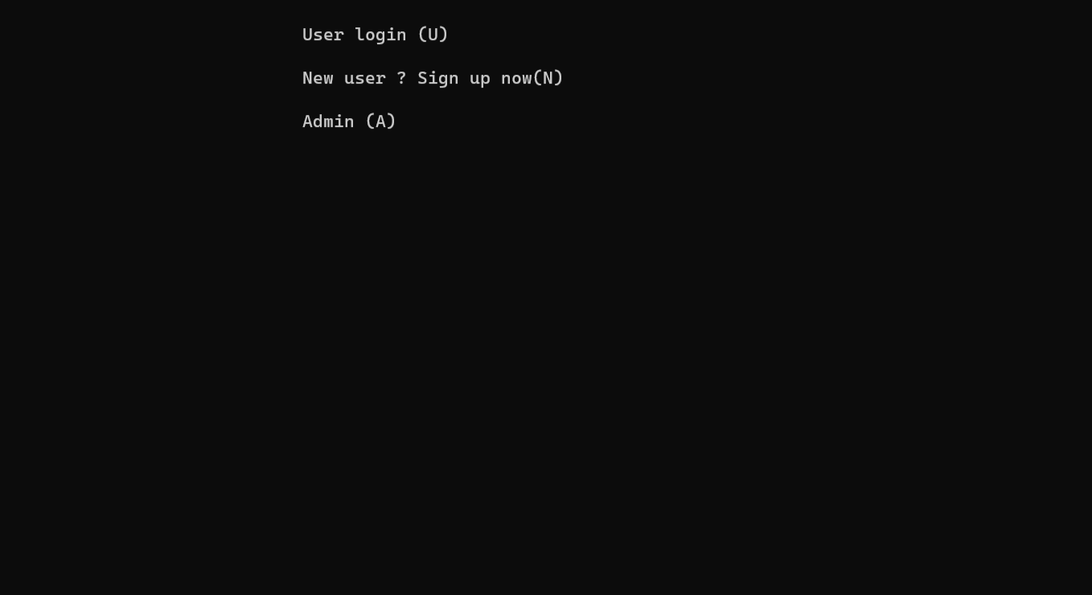

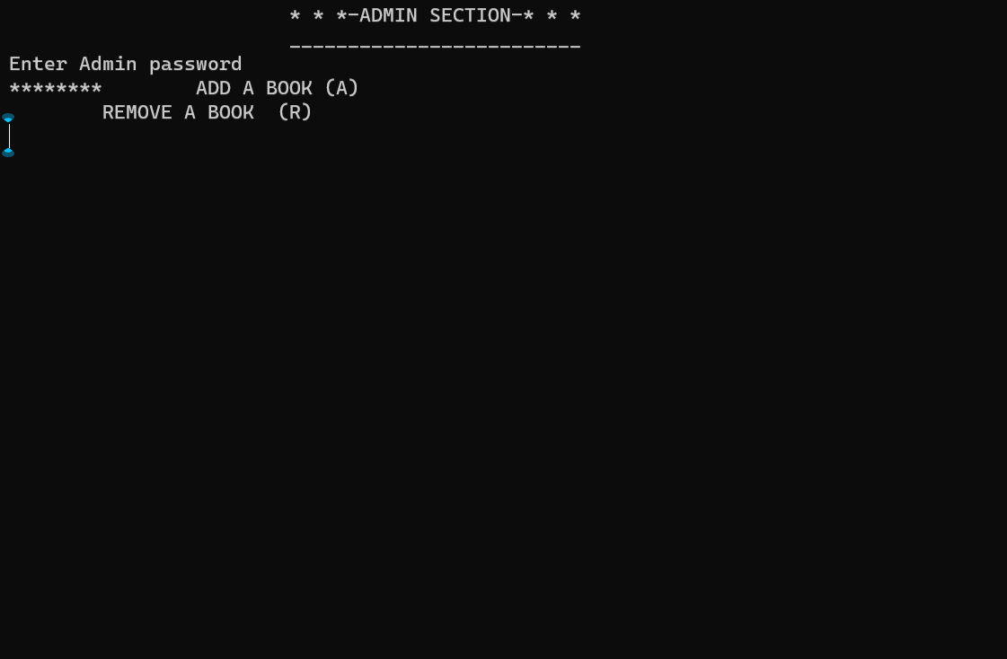

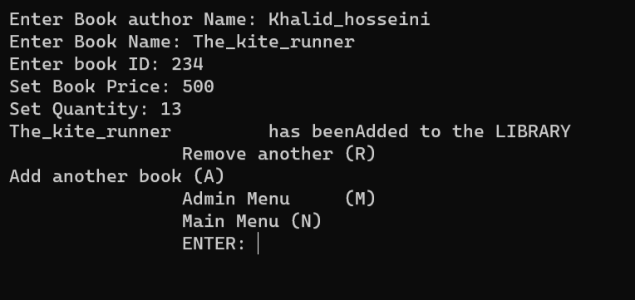

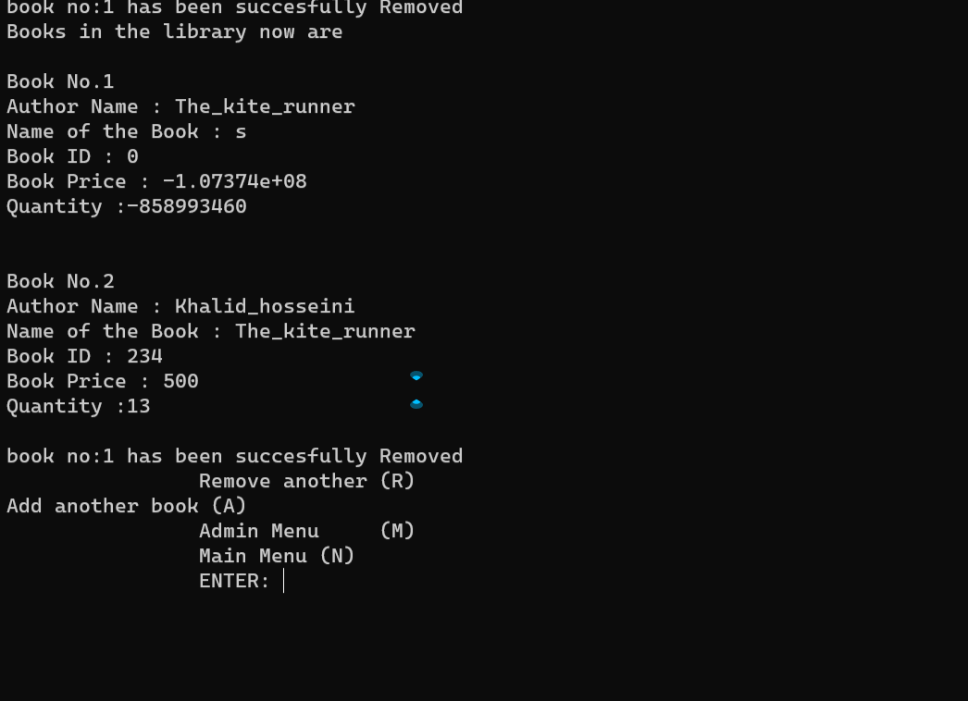

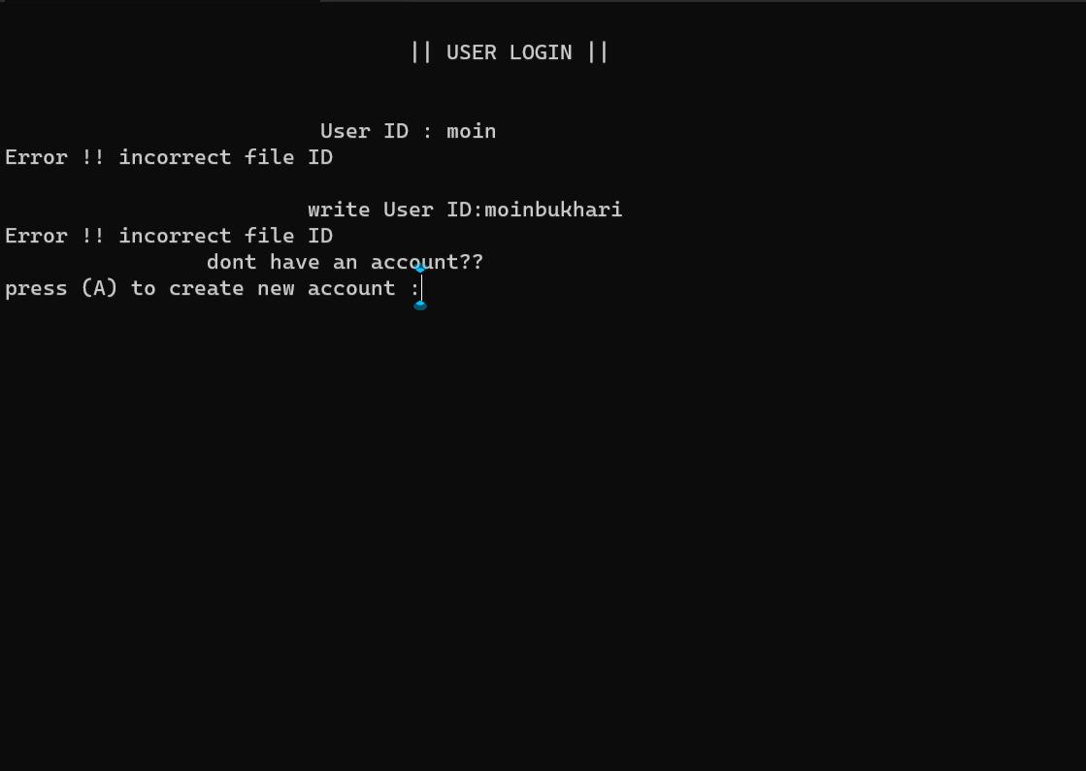



***Flowchart*** :

**welcome message press any key to continue (E)to exit**

USER_OR_ADMIN_OR_NEW USER



Issue function

User id

Book issue

quit

Show function

Search function

Available b

SEARCH

NEW USER FUNCTION

CHECK IDENTIFICATION OF THE USER

NEW USER

T

false

Ask about account

USER LOGIN

Add again

Main Menu

wrong

Remove again

Option to user

Book removed successfully

Remove book

Book added successfully

Add again/remove again

Write all book details to the file

ASK BOOK DETAILS

PASSWORD CHECK

**CHOOSE WHAT TO DO**

**USER**

**ADMIN**

**ENTER PASSWORD**

Ask book no.

User input